 | IQVIATM Work Instruction  Global Regulatory Affairs - Labeling - Creation and maintenance of Company Core Data Sheets  / Company Core Safety Information
Document Number and Revision:
CS_WI_RA0303 Revision 2
Document Owner:  Anja De Pauw | Author(s):  Kiran Chinnalla

PURPOSE
This document describes the process for creation and revision of Company Core Data Sheets (CCDS), Company Core Safety Information (CCSI) or Reference Safety Information (RSI), as applicable.
This document also describes the requirements for harmonizing local/regional labels with the CCDS/CCSI/RSI.

SCOPE
This global Work Instruction (WI) applies to all staff within Global Regulatory Affairs (GRA) and staff in Lifecycle Safety (LCS) and Medical assigned responsibility for tasks related to:

  - Creating, revising, reviewing/approving, and issuing CCDS/CCSI/RSI

  - Harmonizing local/regional labeling with the CCDS/CCSI/RSI

This WI applies to approved pharmaceutical products irrespective of whether they are marketed or not.

ROLES AND RESPONSIBILITIES

Role | Sections
Global Labeling Lead (GLL) | 6.1, 6.2, 6.3, 6.4, 6.5, 6.6, 6.7
Global Regulatory Affairs Lead (GRL)  If a GRL does not exist, the Local/Regional Representative will assume these responsibilities | 6.2, 6.3, 6.4
Global Labeling Committee (GLC) | 6.5
Global Labeling Committee (GLC) Chair | 6.5
Signal Management Specialist/Signal Management Team Member | 6.3
EU QPPV | 6.4
Clinical Subject Matter Expert (SME) | 6.4
Non-Clinical Subject Matter Expert (SME) | 6.4
Quality Subject Matter Expert (SME) | 6.4

Page 1 of 21
Copyright © 2021, 2022. IQVIA. All rights reserved. The contents of this document are confidential and proprietary to IQVIA Holdings Inc. and its subsidiaries. Unauthorized use, disclosure or reproduction is strictly prohibited.

Role | Sections
Regional Coordinator  If a Regional Coordinator does not exist, the Local / Regional Representative will assume these responsibilities | 6.7
Local/Regional Representative  The Regional Coordinator may also assume these responsibilities | 6.7

DEFINITIONS
Company Core Data Sheet (CCDS): A document prepared by the marketing authorization holder (MAH) containing, in addition to safety information, material relating to indications, dosing, pharmacology and other information concerning the product. The CCDS represents the company’s position on the required safety information.
Company Core Safety Information (CCSI): All relevant safety information contained in the CCDS prepared by the MAH and which the MAH requires to be listed in all countries where the company markets the product, except when the local regulatory authority specifically requires a modification. It is the reference information by which “listed” and “unlisted” are determined for the purpose of periodic safety reporting for marketed products, but not by which “expected” and “unexpected” are determined for expedited pharmacovigilance reporting.
Labeling Clinical Overview (LCOV): A document prepared by the MAH to substantiate additions/deletions/modifications to CCDS/CCSI. This document is an addendum to Module 2.5 clinical overview. If a CCDS/CCSI is retrospectively created or remediated, a LCOV may be created depending on the dossier status. A LCOV is not needed for new products in development; Module 2.5 of the dossier will support the new CCDS/CCSI.
Local Label: Local/Regional Labeling refers to labels, including but not limited to, prescribing information, Instructions for Use (IFU), EU Summary of Product Characteristics (SmPC), U.S. Package Insert, and Canadian Product Monograph. Local/Regional Labeling is designed for use by healthcare professionals (HCPs) and patients, and contains the safety and efficacy information for the product.

MATERIAL AND EQUIPMENT
Not Applicable

PROCEDURE

  - Conditions that trigger either creation or update of CCDS/CCSI

No: | Who: | Step: | When:
6.1.1 | GLL | Creates a CCDS if a CCDS does not exist | A branded product is approved in two regions and/or more than two countries.  Or  When deemed necessary by the Market Authorization Holder (MAH).
6.1.2 | GLL | - Identifies one of the major market labels as the Reference Safety Information (RSI).  - Confirms with the MAH if they wish to create a CCSI.  - Create the RSI/CCSI. | The global product is considered a generic product in region/country (i.e. the label must align to the innovator by regulation) and is approved in two regions and/or more than two countries.  Or  When deemed necessary by the MAH.
6.1.3 | GLL | Updates the CCDS/CCSI/RSI | - Receipt of new clinical, non-clinical or pharmacovigilance data including but not limited to, a confirmed safety signal.  - Receipt of information of a new formulation, dose, therapeutic use, or delivery method is to be added to a CCDS/CCSI/RSI  - Receipt of new information that requires CCDS/CCSI revisions as a result of a periodic review
6.1.4 | GLL | - Confirms the periodic review frequency for the CCDS/CCSI based on the product’s risk profile presented in the Periodic Safety Update Report  (PSUR)/Periodic Benefit-Risk Evaluation Report | After a CCDS/CCSI is created or updated

No: | Who: | Step: | When:
(PBRER), as defined/requested by the MAH, or as otherwise determined by the GLC during approval.
- Documents the periodic review frequency in the Project Instruction. Refer to CS_WI_RA0273: Global Regulatory Affairs – – Project Management of Standalone Projects.
6.1.5 | GLL | Conducts a periodic review of CCDS/CCSI to comprehensively review the safety (and efficacy if applicable) profile of the product. | At least every three (3) years for each CCDS/CCSI (with no updates made during this period) or when determined by the GLC
6.1.6 | GLL | - Requests approval of the change in frequency of CCDS/CCSI periodic review from the GLC.  - Documents the revised periodic review frequency in the Project Instruction. Refer to CS_WI_RA0273: Global Regulatory Affairs Project Management of Standalone Projects | The periodic review frequency is proposed to be changed (e.g. from 3 years to 5 years)
6.1.7 | GLL | Confirms with the buyer (i.e. proposed MAH) that the CCDS/CCSI is up to date. If the CCDS/CCSI is not up to date proceed to step 6.2.5  Note: Refer to Appendix A for detailed list of documents/information to be procured from the seller/current MAH. | Prior to change in ownership of CCDS/CCSI for a Market Authorization Transfer (MAT), where IQVIA is supporting the buyer

  - Creation of new CCDS/CSI

No: | Who: | Step: | When:
6.2.1 | GLL | Receives notification of a request to create CCDS/CCSI from the MAH. | At the start of the project
6.2.2 | GLL | Sends the request to SMEs and any additional MAH contact person/s listed in the GRA project files. | Within 1 business day of receipt of the notification
6.2.3 | GLL | Schedules the Kick-off meeting with SMEs, GRL and other stakeholders. | Before initiating the process of CCDS/CCSI  creation
6.2.4 | GRL | Provides to the GLL the list of countries where the product is marketed and the legal basis in each market. | After the Kick-off meeting
6.2.5 | GLL | If required, performs local label comparison if the product is registered/marketed to arrive at common text/content that can be included in the CCDS/CCSI. | Before drafting the CCDS/CCSI

No: | Who: | Step: | When:
6.2.6 | GLL | Creates draft CCDS/CCSI (and LCOV as needed)., using the client’s templates (as the client is the Marketing Authorization Holder) | After reviewing source documents and summary of label comparison
6.2.7 | GRL | Performs Quality Check of the draft CCDS/CCSI. Refer CS_WI_RA032: Global Regulatory Affairs – Preparation,Quality Control and Provision of Regulatory Affairs Deliverables | After creating draft CCDS
6.2.8 | GLL | Go to Section 6.4 for review and approval steps.

  - Update of CCDS/CCSI

No: | Who: | Step: | When:
6.3.1 | GRL | Shares with the GLL new safety and efficacy information:  - Additional studies, new formulation, dose, therapeutic use, or delivery method.  - Pharmacovigilance data including, but not limited to, a confirmed safety signal.  - A revision to a local/regional label based on health authority mandates, local harmonization, updated regulations.  - Identification of new information that requires CCDS/CCSI revisions as a result of a periodic review., such as a drug safety report. | As soon as the new information is identified
6.3.2 | Signal Management Specialist/ Signal Management Team Member | - Communicates the confirmed safety signal to the GLL and GRL.  - Classifies the confirmed safety signal for which a label update is recommended.  Safety signal classifications include:  - Immediate Update  - Non-Immediate Update | On receipt of a Signal Evaluation Report where there is a confirmed safety signal (Day 0)
6.3.3 | GLL | Sets up a meeting with appropriate SMEs if a confirmed safety signal/ new safety/efficacy information has been received | Within 1 business day of receipt of the notification
6.3.4 | GLL | Reviews information and determines with the SMEs if revisions to CCDS/CCSI are required. | During meeting with SMEs
6.3.5 | GLL | Creates a tracking item and enters the safety signal confirmed date into the CCDS Tracking Tool (Refer to Appendix B)  - Immediate Update – CCDS/CCSI/RSI shall be revised and issued within one (1) month of Day 0 of confirmed safety signal | During the meeting with SMEs if CCDS/CCSI  revisions are required or at the periodic review

No: | Who: | Step: | When:
 |  | - Non-Immediate Update including periodic review - CDS/CCSI/RSI shall be revised and issued within three (3) months of Day 0 of confirmed safety signal | date (Refer to 6.16)
6.3.6 | GLL | Creates draft CCDS/CCSI (and LCOV as needed) based on supporting information. | CCDS/CCSI  revisions are required
6.3.7 | GRL | Performs Quality Check of the draft CCDS/CCSI. Refer CS_WI_RA032: Global Regulatory Affairs – Preparation,Quality Control and Provision of Regulatory Affairs Deliverables. | After creating draft CCDS
6.3.8 | GLL | Identifies timeframe for the submission of harmonized local/regional label based on updated CCDS content:  - Immediate Update – Local/regional label shall be revised and submitted within 60 calendar days of issuance of CCDS/CCSI/RSI.  - Non-Immediate Update (CCDS Tracking Tool priority: Accelerated)– Local/regional label shall be revised and submitted within 90 calendar days of issuance of CCDS/CCSI/RSI.  - Other Update– Local/regional label shall be revised and submitted within 120 calendar days of issuance of CCDS/CCSI/RSI.  Note: Timeframe may be adjusted based on MAH requirement | The CCDS/CCSI  changes trigger safety variations
6.3.9 | GLL | Revises the local/regional label and provides to the Local/Regional Representative  Note:  - This is not applicable for safety signal updates.  - The timeframe may be adjusted based on MAH requirement | Within 180 calendar days of issuance of the standard new Core CCDSS/CCSI
6.3.10 | GLL | Go to Section 6.4 for review and approval steps

  - Cross- Functional Review and Approval of new/updated CCDS/CCSI/RSI (and LCOV as needed)

No: | Who: | Step: | When:
6.4.1 | GLL | Distributes the (new/updated) CCDS/CCSI review package to the SMEs for review. | Draft CCDS/CCSI/RSI/  LCOV available for review

No: | Who: | Step: | When:
6.4.2 | Clinical SME | Reviews the clinical sections and associated supporting documents/literature for CCDS/CCSI sections related to indications, dosage and method of administration, use in special population, pharmacodynamics, pharmacokinetics, Drug-Drug/Drug-Food/Drug- Container interactions.  Provides documented comments to GLL. | Upon receipt of the draft CCDS/CCSI/ RSI/LCOV
6.4.3 | EU QPPV | Reviews the safety sections and associated supporting documents/literature for CCDS/CCSI sections related to contraindications, special warnings and precautions, use in special population, adverse reactions, overdose, abuse, misuse and dependency.  Provides documented comments to GLL. | Upon receipt of the draft CCDS/CCSI/ RSI/LCOV
6.4.4 | Non- clinical SME | Reviews the pre-clinical sections and associated supporting documents/literature for CCDS/CCSI sections related to pregnancy, lactation, fertility, pre-clinical studies.  Provides documented comments to GLL. | Upon receipt of the draft CCDS/CCSI/ RSI/LCOV
6.4.5 | Quality SME | Reviews the quality sections related to qualitative and quantitative information, stability, shelf-life, excipients and active ingredients, pack sets, storage, lot/batch number, expiry date, license numbers.  Provides documented comments to GLL. | Upon receipt of the draft CCDS/CCSI/ RSI/LCOV
6.4.6 | GRL | Reviews the overall CCDS/CCSI in line with Regulatory strategy and intelligence.  Provides documented comments to GLL. | Upon receipt of the draft CCDS/CCSI/ RSI/LCOV
6.4.7 | GLL | Consolidates the comments from SMEs and, if required, schedules cross-functional review meeting(s). | Upon receipt of the review comments from all SMEs
6.4.8 | GLL | Return to step 6.4.1. | Revisions to CCDS/CCSI or  LCOV required
6.4.9 | GLL | Distributes review package to the SMEs for final review and approval. | No additional CCDS/CCSI  and/or LCOV revisions are necessary
6.4.10 | GLL | Proceeds to step 6.6.1 to track and file the CCDS/CSI. | There were only administrative and quality updates to the CCDS/CCSI without effect on safety and efficacy content.

No: | Who: | Step: | When:
6.4.11 | GLL | Schedules a GLC review meeting and distributes the review package to the GLC | There are updates to the CCDS/CCSI  impacting the safety and efficacy content.

  - GLC Review and Approval of new/updated CCDS/CCSI/RSI

No: | Who: | Step: | When:
6.5.1 | GLC | Reviews (new/updated) CCDS/CCSI/RSI package for approval. Provides comments and/or changes to GLL, as needed. | Prior to GLC meeting
6.5.2 | GLL | Presents the CCDS along with LCOV to the GLC members via a PowerPoint presentation. | During the GLC meeting
6.5.3 | GLL | Communicates the recommendations suggested by GLC to the respective SMEs. | Post GLC meeting
6.5.4 | GLL | Returns to Section 6.4 step 6.4.7. | Post GLC meeting if SME update required to CCDS/CCSI
6.5.5 | GLL | Updates the CCDS/CCSI/LCOV and requests GLC approval. | Post GLC meeting, if non- SME updates are required to CCDS/CCSI
6.5.6 | GLC  Chair | Documents GLC approval in CCDS Tracking tool and notifies the GLL. | After GLC Approval

  - Tracking and filing of approved CCDS/CCSI/RSI/LCOV

No: | Who: | Step: | When:
6.6.1 | GLL | - Distributes the final CCDS package to registered/marketed countries for local label implementation.  - Creates tracking item, including CCDS/CCSI/RSI identifier in CCDS Tracking Tool.  - Uploads approved documents to client or IQVIA document repository system, as applicable.  - Verifies that the CCDS/CCSI/RSI approval date has been entered in the CCDS Tracking Tool. | After GLC Approval

  - Harmonize Local/Regional Labels with the new/updated CCDS/CCSI/RSI
This harmonization step is also known as the implementation step of the CCDS/CCSI/RSI into local/regional labels. For principles to consider harmonizing local/regional labeling with CCDS/CCSI/RSI, refer to Appendix C.

No: | Who: | Step: | When:
6.7.1 | Local/Regional Representative or Regional Coordinator | Verifies country registration status. | On receipt of approved CCDS and prior to the submission date, as applicable.
6.7.2 | Local/Regional Representative or Regional Coordinator | Requests an exemption to the GLL and no further action is required. | The product is not registered in the country
6.7.3 | Local/Regional Representative or Regional Coordinator | Determine if country is dependent upon a source country. | The product is registered in country or has a new registration pending in country
6.7.4 | Local/Regional Representative or Regional Coordinator | Conducts a gap analysis comparing the local/regional label against the CCDS/CCSI/RSI. | There is no dependency upon a source country
6.7.5 | Local/Regional Representative or Regional Coordinator | Submit a dependency request to GLL. | There is a dependency upon a source country
6.7.6 | Local/Regional Representative or Regional Coordinator | Requests an exemption from the GLL in writing if changes are already incorporated in the country label and no label changes are required. No further action is required. | Prior to the submission date
6.7.7 | Local/Regional Representative or Regional Coordinator | Identifies required revisions to the local/regional label. Updates the local/regional label to align with the CCDS/CCSI/RSI, if applicable. | Changes are required to the local/regional label
6.7.8 | Local/Regional Representative or Regional Coordinator | Prepares a deviation request (including justification) and submits the deviation request to the GLL.  Reffer to: Appdendix E: Content Deviation Request Form | The local/regional label deviates from the CCDS/CCSI/RSI

No: | Who: | Step: | When:
6.7.9 | GLL | - Consults SMEs to gain approval of deviation request.  - Informs the Local/Regional Representative that the Exemption is agreed.  - Documents this agreement in the CCDS Tracking Tool. | Receipt of deviation request
6.7.10 | Local/Regional Representative or Regional Coordinator | Requests an exemption via the CCDS Tracking Tool as needed. | The deviation is applicable to all mandatory CCDS/CCSI/RSI  changes
6.7.11 | Local/Regional Representative or Regional Coordinator | - Completes a Deferral request form (Refer to Appendix D) if there is a justifiable reason that the local/regional label cannot be submitted by the submission due date.  - Submits the Deferral request to the GLL. | Prior to the submission due date
6.7.12 | GLL | - Consults SMEs to gain approval.  - Informs the Local/Regional Representative that the deferral is agreed.  - Documents this agreement in the Deferral request form and the CCDS Tracking Tool. | Receipt of Deferral request
6.7.13 | Local/Regional Representative or Regional Coordinator | Prepares the local/regional label submission (e.g. labeling variation) if changes are required to the local/regional label. Refer to CS_WI_RA0279: Global Regulatory Affairs -  Regulatory Submissions - Post Approval Changes to Registered Details including CMC,  Administrative and Safety Changes. | Within the required timeframe associated with each country
6.7.14 | Local/Regional Representative or Regional Coordinator | Submits the revised labeling to the Health Authority (HA) and enters the submission date into CCDS Tracking Tool. | After submission of the revised local/regional label
6.7.15 | Local/Regional Representative or Regional Coordinator | Identifies if the proposed changes requested by the HA result in the local/regional label deviating from the CCDS/CCSI/RSI. | During negotiations with the HA
6.7.16 | Local/Regional Representative or Regional Coordinator | Completes and submits deviation request to GLL. | Agreement with GLL cannot be met on all or some of the changes proposed in order to align with the CCDS/CCSI/RSI

No: | Who: | Step: | When:
6.7.17 | GLL | - Consults SMEs to gain approval  - Informs the Local/Regional Representative that deviation is agreed.  - Documents this agreement in the CCDS Tracking Tool. | Receipt of deviation request
6.7.18 | Local/Regional Representative or Regional Coordinator | Request an exemption via the CCDS Tracking Tool as needed. | The deviation is applicable to all mandatory CCDS/CCSI/RSI  changes
6.7.19 | Local/Regional Representative or Regional Coordinator | Receives approval from the HA for the local/regional label. | After HA has completed their assessment
6.7.20 | Local/Regional Representative or Regional Coordinator | Enters HA submission approval date in the CCDS Tracking Tool. | After receipt of HA approval
6.7.21 | Local/Regional Representative or Regional Coordinator | Completes and submits Deviation request to GLL. | The approved label from the Competent Authority deviates from the CCDS/CCSI/RSI
6.7.22 | GLL | - Consults SMEs to gain approval  - Informs the Local/Regional Representative that Exemption is agreed.  - Documents this agreement in the CCDS Tracking Tool. | Receipt of deviation request
6.7.23 | Local/Regional Representative or Regional Coordinator | Enters the Implementation into Packaging date in the CCDS Tracking Tool | The label has been implemented on the product

- SUPPORTING DOCUMENTATION

DOCUMENT NUMBER | TITLE
ESOP References
7.1 CS_WI_RA0273 | Global Regulatory Affairs – Project Management of Standalone Projects
7.2 CS_WI_RA032 | Global Regulatory Affairs – Preparation, Quality Control and Provision of Regulatory Affairs Deliverables
7.3 CS_WI_RA0279 | Global Regulatory Affairs - Regulatory Submissions - Post Approval Changes to Registered Details including CMC,

DOCUMENT NUMBER | TITLE
 | Administrative and Safety Changes
External References
7.4 EU-GVP | Annex I - Definitions
7.5 EU-GVP | Module VII – Periodic safety update report
7.6 EU-GVP | Module IX – Signal management
7.7 ICH-E2C R2 | Periodic Benefit-Risk Evaluation Report (PBRER)

- SUPERSEDES

DOCUMENT NUMBER | TITLE | REVISION NUMBER
8.1 CS_WI_RA0303 | Global Regulatory Affairs - Labeling - Creation and maintenance of Company Core Data Sheets / Company Core Safety Information | 1

- MODIFICATION FROM PREVIOUS REVISION

CHANGE | SECTION REFERENCE | JUSTIFICATION
Appendix E Content Deviation Request Form | 10 | For consistency across GRA- owned WIs
Appendix F (flowcharts) added | 10 | For consistency across GRA- owned WIs

- APPENDICES

  - Appendix A: Market Authorization Transfer – List of document to be procured from the Seller

  - Appendix B: CCDS Tracking Tool - Tracking Fields

  - Appendix C: Principles to consider harmonizing local/regional labeling with CCDS/CCSI/RSI

  - Appendix D: Submission Deferral Form

  - Appendix E: Content Deviation Request Form

  - Appendix F: Flowcharts

Appendix A: Market Authorization Transfer – List of document to be procured from the Seller

 | Name of Document | Versions | Rationale for procurement
1. | Company Core Data Sheet (CCDS)/  Company Core Safety Information (CCSI)/ Reference Safety Information (RSI) | Current approved version (Track change and Clean renditions); Note: Up to date CCDS (with up to date efficacy and safety data; also considering if there are ongoing/completed Post authorization efficacy and safety studies)  All the older/superseded versions available (Track change renditions) | Older/superseded versions of the CCDS/CCSI/RSI would help in understanding the background of safety information present in the Core.
2. | Labeling Justification Documents (JD)/Clinical Overviews Addendums (ACO)/Clinical Overviews (CO) | CO/JD/ACO corresponding to the latest approved version of the CCDS. As well as all the older JD’s supporting the update superseded versions of the CCDS | The JD would provide history and rationale for the new/existing safety text within the CCDS.
3. | Signal Evaluation reports (SER) | For all the signals that were confirmed during lifecycle management of the molecule | Will provide rationale for inclusion of existing safety information.
4. | CCDS change Log | Latest version of the CCDS change log | To get a comprehensive list of updates made to the Core along with the effective dates of each change.
6. | Labeling Decision Document | All available versions | Any documented decisions for inclusion/exclusion of safety/efficacy information in the Core.

 | Name of Document | Versions | Rationale for procurement
7. | Labeling Comparison documents | Latest available version | Any comparisons between latest approved CCDS and Marketed labels of the product with rationales provided for all discrepancies between CCDS and Marketed Label (i.e. Safety variation submitted in a particular region; Stricter wording in SmPC than in CCDS due to this document being available to HCPs; Any decision on inclusion of data from clinical trial or post- marketing surveillance in only one section)
8. | English Translations of Local/regional labels: Prescribers Information, Patent Labels, Labeling Text, promotional materials | Latest HA approved version | For a comprehensive understanding of the safety/efficacy information of the product (regional labeling exceptions)
9 | Ongoing/completed HA recommendations, safety communications, Safety/labeling HA Q&A | All available versions | For a comprehensive understanding of the safety/efficacy information of the product (regional labeling exceptions)
10 | Substance and product details | List of Products (Including quality composition) with trade names and approved Indications for registered and marketed countries. | To have a comprehensive understanding of all available: Actives along excipients with different strengths, Pharmaceutical forms, route of administrations, formulations, and pack set representation.
11 | List of ongoing/pending local labeling changes | Ongoing/pending | To have a better Compliance oversight (implementation of core to local label changes) and possible triggers for CCDS update.

Appendix B: CCDS Tracking Tool - Tracking Fields

- Active substance
- Trade name
- Pharmaceutical Form & Strengths
- Request Created Date
- Day 0 (If applicable)
- Global Impact Assessment Date
- GLC Approval Date
- CCDS Sign- off Date
- CCDS Distribution Date
- Country(ies) Acknowledgement Date
- Country Dependency
- Local Impact Assessment Date
- Reason for Submission Deferral
- Justification for submission deferral (If any)
- Deferral Rejection/Approval Date
- LPD Sign-off Date - English
- Translated LPD Sign- off Date - Non English (If Applicable)
- HA Submitted/ Notified Date
- HA Last Corresponds Date
- Label Public Listed Date
- Commercial Artwork Sign-off Date
- Commercial Artwork intake form Approved
- Last Artwork of a SKU Approved
- Bill of material changed over (BOM)
- First batch released at package site
- Available to ship from last point of control
- First Ship with New Artwork
- Last ship with old Artwork

Appendix C: Principles to consider harmonizing local/regional labeling with CCDS/CCSI/RSI

- Local/regional labeling should be consistent with CCDS/CCSI/RSI content based on the following:
  - “Placement” refers to the message placed in an equivalent section in local/regional labels that would convey the same importance message consistent with the CCDS/CCSI/RSI
  - “Tone” refers to intended emphasis
  - “Meaning” refers to same or consistent message being conveyed
- Verbatim wording is identified in the CCDS/CCSI/RSI as bold and italicized text. It is intended to be incorporated word for word in local/regional labeling and may only be modified if required by the Competent Authority

- Mandatory information is identified in the CCDS/CCSI/RSI as bold text. This language must be included in local/regional labeling in a form that is consistent with the content of the CCDS/CCSI/RSI in terms of placement in an equivalent section, tone and meaning

- Recommended text will be identified in the CCDS/CCSI/RSI by plain text and should be included in the local/regional labels but is not required, if rejected by the Competent Authority (CA) during negotiations. No formal deviations are required if the recommended text is not included in the local/regional label

- Deviations (information that differs from the CCDS/CCSI/RSI in terms of placement, tone, and/or meaning) shall be identified and appropriate justification shall be documented (i.e. requirements by local/regional authorities)

Appendix D: Submission Deferral Form

CCDS/CCSI Title CCDS/CCSI Number
Country(ies) Requesting Deferral
Section 1 – Justification for Submission Deferral
- Describe Submission Deferral request:
- Select reason for Submission Deferral:
Pending Registration Current CA Activity
Supporting Documents Missing/Needed Regional Strategy
Product Transfer Other
- Original submission due date DD/MMM/YYYY (e.g., 17JUN2018):
- Prior Submission Deferrals? Y or N. If Y, summarize Submission Deferral dates/history:
- Provide justification for Submission Deferral:
Proposed submission date: DD/MMM/YYYY (e.g., 17JAN2019):

Section 2 – Regional Coordinator or Designee Signature
Title | Print Name | Signature | Date
Regional Coordinator
(or designee)
Section 3 – Submission Deferral Approvals
Title | Print Name | Signature | Approval Date
Global Regulatory Leader (GRL)
Global Labeling Lead (GLL) (or designee)
Other or N/A:
Print, sign and date your approval. Return signed Submission Deferral Form to Regional Coordinator (or designee). Regional Coordinator (or designee) to forward fully signed Submission Deferral Form to GLL

Appendix E: Content Deviation Request Form

CCDS/CCSI title: : CCDS/CCSI Number
Country(ies) Requesting Content Deferral:
Section 1 – Justification for Content Deviation
CCDS/CCSI Text | Local/Regional Label Text
Section Number: | Section Number
Reason/Justification:

Section 2 – Regional Coordinator or Designee Signature
Title | Print Name | Signature | Date
Regional Coordinator
(or designee)
Section 3 – Content Deviation Approvals
Title | Print Name | Signature | Approval Date
Global Regulatory Leader (GRL)
Global Labeling Lead (GLL) (or designee)
Other or N/A:
Print, sign and date your approval. Return signed Content Deviation Request Form to Regional Coordinator (or designee). Regional Coordinator (or designee) to forward fully signed Content Deviation Request Form to GLL

Appendix F: Flowcharts

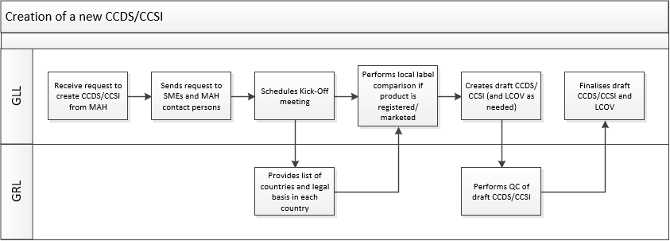

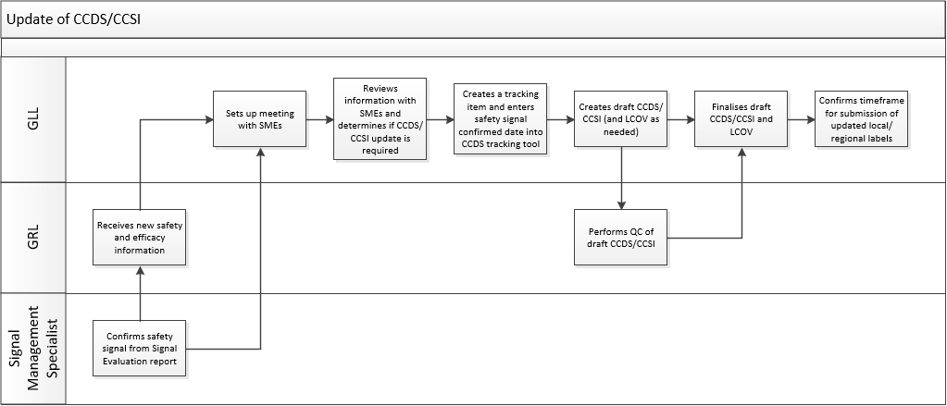

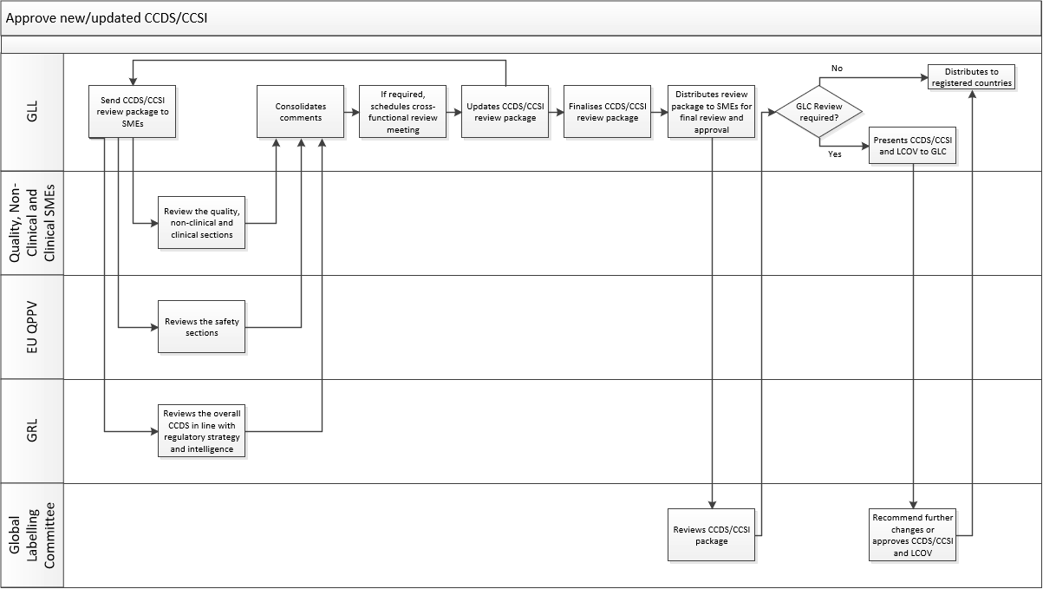

UserName: Corley, Helen (q730385) Title:
Date: Friday, 25 March 2022, 12:42 PM Eastern Daylight Time Meaning: Signing this Document Indicates My Approval
================================================

UserName: Dobrychlop, Karolina (q1025820) Title:
Date: Monday, 28 March 2022, 03:15 AM Eastern Daylight Time Meaning: Signing this Document Indicates My Approval
================================================

UserName: Lewicky, Tamara (q730348) Title:
Date: Monday, 28 March 2022, 05:23 AM Eastern Daylight Time Meaning: Signing this Document Indicates My Approval
================================================

UserName: Nandikonda, Sruthi (u1076598) Title:
Date: Monday, 28 March 2022, 08:57 AM Eastern Daylight Time Meaning: Signing this Document Indicates My Approval
================================================

UserName: Kennedy, Jillian (q600133) Title:
Date: Monday, 28 March 2022, 02:19 PM Eastern Daylight Time Meaning: Signing this Document Indicates My Approval
================================================

UserName: Glizer, Veronica (q735279) Title:
Date: Tuesday, 29 March 2022, 10:28 AM Eastern Daylight Time Meaning: Signing this Document Indicates My Approval
================================================

